**03/24/2020**

**KrishnaPriya Parumanchala**

**1808721**

**Error Resolving and Changes in Fabcar**

Making changes to chaincode go files and fabcar javascript folders

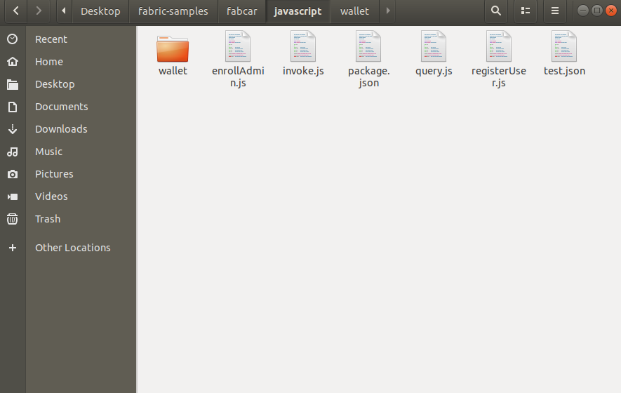

**Setting up the respective path for ./test.json**

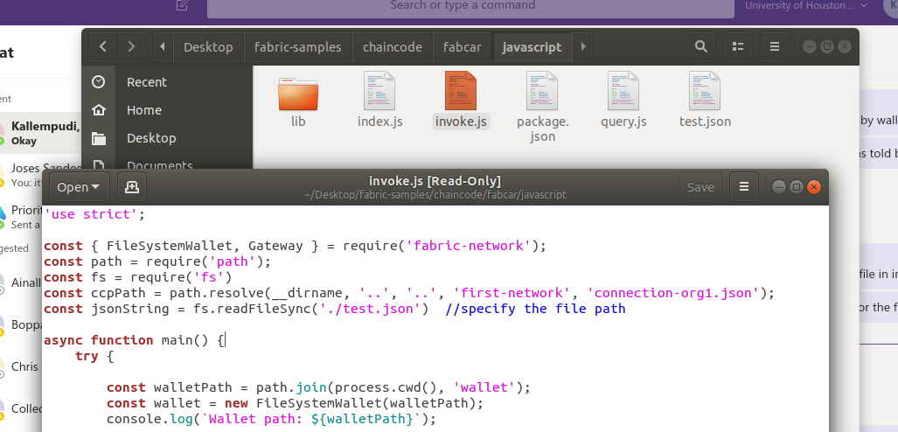

Errors while executing enrollAdmin.js

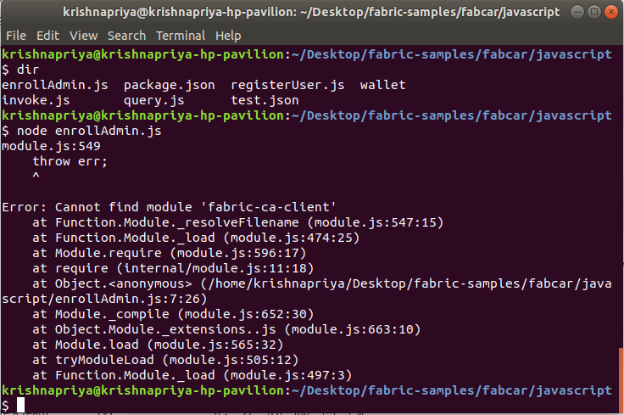

Checking to see whether fabric-ca-client module installed in node_modules or not

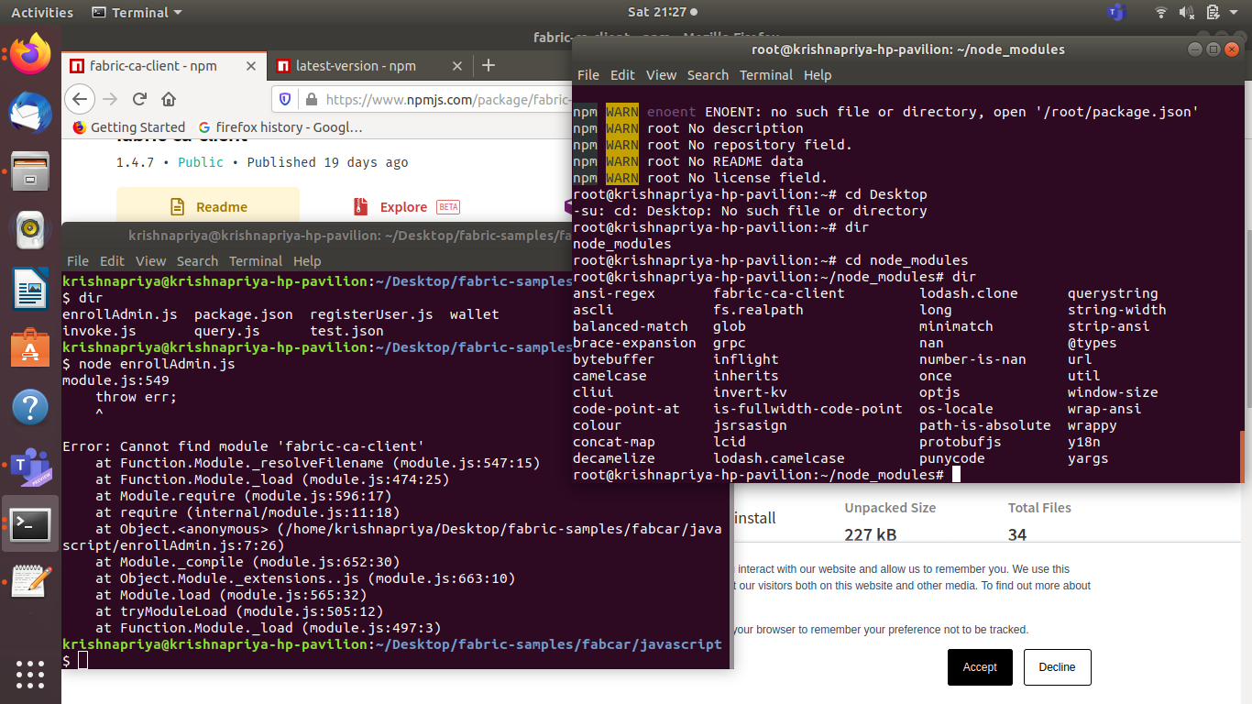

Staring fabric once again to check for more specific errors

Referring to npm website to study on ‘fabric-ca-client’ and install it again to solve errors

This again checks for RPC errors and if not found installs it in the system.

